Volcanoes
- A volcano is _________________________________________________________________.
- Label the diagram of the volcano with the following terms:
crater | lava | magma
main vent | vent | volcanic ash

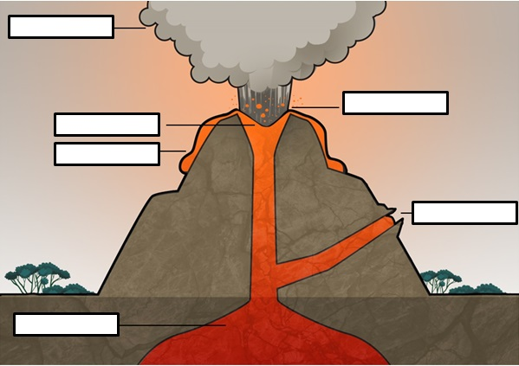
- Complete the organiser below after viewing the video Mount St. Helens. Remember to use your science knowledge.
Volcanoes
What erupted out of Mount St. Helens?
What happened with the eruption material?
How are volcanoes monitored?
How can a volcano change the surface of Earth?
Apply your knowledge of volcanoes.
Would this eruption be classified as a natural disaster? Explain your answer.
List negative impacts of volcanic eruptions.
List positive impacts of volcanic eruptions.

